The Great War (World War I or The First World War) (1914-18)
The Great War was fought from 1914 to 1918, and officially ended in 1919 when the Treaty of Versailles was signed. The primary locus for the conflict was the trench war on the Western Front between the Entente Powers (the British, French, and Russian empires, the US from 1917, and many other nations) and the Central Powers (the German, Austro-Hungarian, and Ottoman Empires and Bulgaria). By the time the armistice was signed at Compiègne, at 11am on 11 November 1918, almost nine million combatants had been killed. Many modernist authors fought in the war, and some died; others were nurses, ambulance drivers and reporters. The war was a defining event, and its impact was unavoidable in Europe. That impact was felt in literature at the levels of content and form, in modernist prose and poetry, by men and women, combatants and civilians.

War Timeline

3 Aug 1914 July-Nov 1916 Mar-Jun 1918 11 Nov 1918
Britain declares Battle of German spring Armistice signed
war on Germany the Somme offensive at Compiègne
| | | | | | |
April-May 1915 July-Nov 1917 Aug 1918
First Battle of Ypres Third Battle British
inc. first use of of Ypres breakthrough
gas by Germans (Passchendaele) at Albert

Literary Timeline

1914 1916 1918 1922
H.G. Wells, Wells, Mr Britling Rebecca West, Return C.E. Montague
The War That Will Sees It Through; Rose of the Soldier; Arnold Disenchantment;
End War Macaulay, Non- Bennett, The Pretty Lady; Ernest Raymond,
Combatants & Others Siegfried Sassoon, Counter Tell England; T.S.
Attack & Other Poems Eliot, The Waste Land
| | | | | | |
1915 1917 1920
Rupert Brooke, Siegfried Sassoon, D.H. Lawrence,
1914 & Other The Old Huntsman; Women in Love;
Poems Edward Thomas, Wilfred Owen,
Poems Poems

1924-8 1928 1930 1937
Ford Madox Ford, Erich Maria Remarque, Siegfried Sassoon, David Jones, In
Parade’s End All Quiet on the Western Memoirs of an Infantry Parenthesis
tetralogy Front; R.C. Sherriff, Officer; Frederic Manning,
Journey’s End Her Privates We
| | | | | | |
1925 1929 1933
Virginia Woolf, Richard Aldington, Vera Brittain,
Mrs Dalloway Death of a Hero; Robert Testament of Youth
Graves, Goodbye to All
That; Ernest Hemingway,
A Farewell to Arms
The assassination on 28 June 1914 of Archduke Franz Ferdinand, the Austro-Hungarian heir presumptive, was the spark which ignited the tinder-dry antagonisms of the major European powers. The tensions behind the conflict had grown over the previous century, from the end of the Napoleonic wars in 1815, through the Franco-Prussian War of 1870-1, to the series of treaties between the major powers of Europe which were subsequently established. War between Britain and Germany was prophesied in late nineteenth- and early twentieth-century invasion literature such as Erskine Childers’ The Riddle of the Sands (1903) and William Le Queux’s popular The Invasion of 1910 (1906); E.M. FORSTER alludes to the possibility in Howards End (1910).

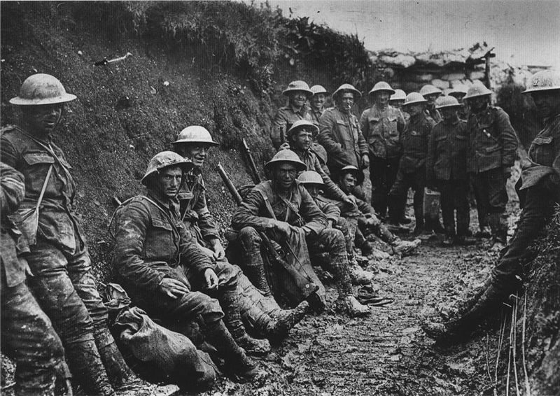
The onset of war was initially greeted with enthusiasm by groups of patriots on both sides, and by some intellectuals who believed that war would purify a decadent society. Enthusiasm was not all-encompassing, however: dissent was registered in public and private, by individuals and organizations, in speeches and in print. There was a brief initial phase of movement in the war, but by the end of 1914 the trench system was well-established, stretching for hundreds of miles through France. The Western Front has become synonymous with the experience of the Great War and the majority of the military force was focused there, although campaigns were also fought in Africa, Asia, the Balkans, and the Middle East. The antagonists struggled to come to terms with the best way to deploy recently-developed technology such as machine-guns, heavy artillery and tanks, and with the scale on which the war was fought. The first day of the Battle of the Somme, 1 July 1916, saw some of the bloodiest fighting in modern history. It was not until 1918, as the war threatened to stretch into the subsequent decade, that movement returned: the Central Powers appeared to take the upper hand early in the year, before the Entente Powers broke through decisively in August and then October.

Modernist Deaths in the Great War

1914 1916 1918
Alfred Lichtenstein, Alan Seeger, Isaac Rosenberg,
Charles Péguy Umberto Boccioni Wilfred Owen,
Guillaume Apollinaire
| | | | |
1915 1917
Rupert Brooke, T.E. Hulme,
Charles Hamilton Sorley, John McCrae,
Henri Gaudier-Brzeska Edward Thomas
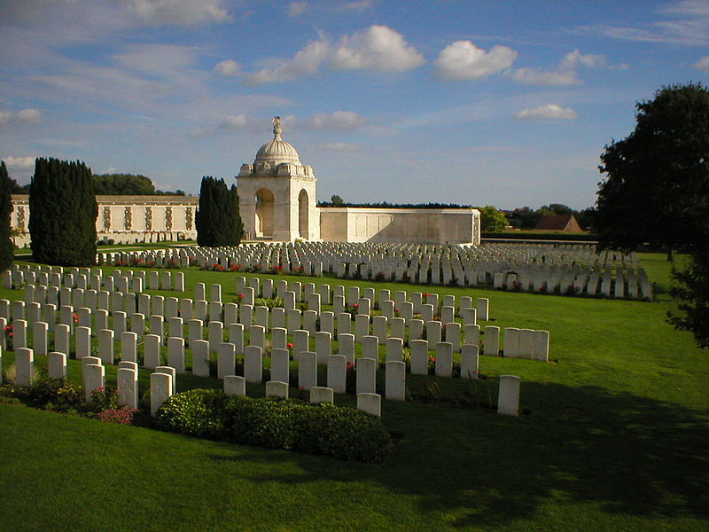
The war was not an ellipsis in modernism: even those who served continued to write prose and poetry for volume publication and for literary journals. Richard ALDINGTON remained editor of the Egoist until 1918, sharing duties with H.D. after his 1916 departure for the Western Front; Ford Madox FORD continued to write throughout his service in Britain and France. Outside the usual purview of high modernism, Siegfried SASSOON and Edward Thomas both published collections of poetry in 1917 and 1918, the latter posthumously.

Authors responded to the war from its beginning in a variety of forms and moods. Non-combatant authors were able to write extensively about the conflict earlier than those who chose or were compelled to fight. H.G. WELLS’s pamphlet The War That Will End War (1914) became an enduring phrase, and the failure to achieve a lasting and satisfactory peace contributed to subsequent disillusionment. His Mr Britling Sees It Through (1916) is a nuanced depiction of the beginning of the war, which shows the complex and finely-balanced equilibrium of the pre-war world, and the ongoing debates of those years. It was a bestseller in the US and the UK; other popular novels such as John Buchan’s Greenmantle (1916) and Arnold BENNETT’s The Pretty Lady (1918) offer a more subtle take on the conflict than is often credited. Authors who remained outside official structures were more able to speak against the war. Married to a German, D.H. LAWRENCE was subject to intense scrutiny, and wrote as early as 1915 about the flawed country for which the war was being fought in ‘England, My England’; Rose MACAULAY’s Non-Combatants and Others (1916) deals with pacifism in Britain, and Rebecca WEST’s The Return of the Soldier (1918) is an early novel to deal with the fear of and problems endured by returning combatants.

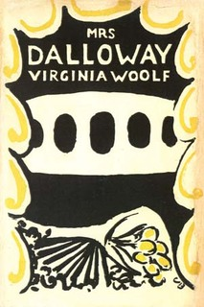
Post-war modernist writing often fragments language and narrative. The ellipses used by FORD and WOOLF highlight a concern with mental processes which finds a new focus in shell shock. Shifts of time and space signal the difficult relationship between the Western Front and the home front and changes in ways of understanding the physical world. LAWRENCE’s Women in Love (1920) does not mention the war, but deals with passionately-felt, violent interactions between English and German protagonists, while T. S. ELIOT’s The Waste Land (1922) has in mind a wider context of decay and degeneration. Virginia WOOLF’s novels of the nineteen twenties address the impact of the war on individual lives and social structures; Jacob’s Room (1922), Mrs Dalloway (1925) and To the Lighthouse (1927) might be considered a trilogy of war novels. These were elite discourses, however, and the popular novel largely remained loyal to traditional forms: Gilbert Frankau’s Peter Jackson, Cigar Merchant (1919) reasserts the value of vigorous capitalism and patriarchal heteronormativity, and the bestselling novel of the nineteen twenties in the UK was Ernest Raymond’s Tell England (1922), a bildungsroman about Christian heroism and endurance.

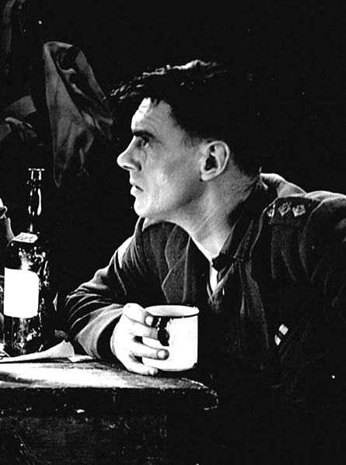
Many combatant authors took longer to write about war, although C.E. Montague was able to criticize the war strongly in Disenchantment (1922), an early move away from the heroic mode. Ford Madox FORD’s Parade’s End tetralogy (1924-8) defines the early combatant response to the war; using modernist techniques Ford sees the conflict in the light of the uncertain Edwardian world and the difficulties of post-war readjustment. Using a similar family saga form, R.H. Mottram’s The Spanish Farm Trilogy is a middlebrow classic, combining Victorian form with modernist metaphor.

The ‘War Books Boom’ of 1928-30 saw an outpouring of war literature which criticized the conduct of military and political hierarchies. Influential in stimulating this were Erich Maria REMARQUE’s All Quiet on the Western Front (1929), first serialized on the tenth anniversary of the armistice and soon a bestseller in translation across Europe, and R.C. Sherriff’s play Journey’s End (1928). Richard ALDINGTON’s Death of a Hero (1929) and Ernest HEMINGWAY’s A Farewell to Arms (1929) were early novels to capitalize on the interest generated, and were quickly followed by works such as Robert GRAVES’s Goodbye to All That (1929) and Siegfried SASSOON’s Memoirs of an Infantry Officer (1930), the second of his Sherston trilogy; Frederic Manning’s The Middle Parts of Fortune (1930) draws on Journey’s End for its structure and recasts it in the style of a service record. The films of the two successes which precipitated the boom contributed to its decline in the latter part of 1930. The focus was already on looking towards a new war, although notable responses to the Great War such as Vera BRITTAIN’s Testament of Youth (1933) and David JONES’s In Parenthesis (1937) continued to appear. D.H. LAWRENCE described the war in Lady Chatterley’s Lover (1928) as the ‘bruise slow to heal’, and the impact of the Great War left an indelible mark on the twentieth century.

Histories of the Great War
Gregory, Adrian (2008). The Last Great War: British Society and the First World War. Cambridge: Cambridge University Press.
Kennedy, David M. (2004 [1980]). Over Here: The First World War and American Society. New York: Oxford University Press.
Holmes, Richard (2005). Tommy: The British Soldier on the Western Front, 1914-1918. London: Harper Perennial.
Strachan, Hew (2003). The First World War: A New Illustrated History. London: Simon & Schuster.
Todman, Dan (2005). The Great War: Myth and Memory. London: Continuum.

Selected Literary and Cultural Criticism about the Great War
Bond, Brian (2002). The Unquiet Western Front: Britain’s Role in Literature and History. Cambridge: Cambridge University Press.
Cobley, Evelyn (1993). Representing War: Form and Ideology in First World War Narratives. Toronto: University of Toronto Press.
Eksteins, Modris (2000 [1989]). Rites of Spring: The Great War and the Birth of the Modern Age. Boston, New York: Houghton Mifflin.
Hynes, Samuel (1990). A War Imagined: The First World War and English Culture (New York: Collier Books / Macmillan.
Sherry, Vincent (2003). The Great War and the Language of Modernism. Oxford: Oxford University Press.
Sherry, Vincent (ed.) (2005). The Cambridge Companion to the Literature of the First World War. Cambridge: Cambridge University Press.
Smith, Angela K. (2000). The Second Battlefield: Women, Modernism and the First World War. Manchester: Manchester University Press.
Tate, Trudi (1998). Modernism, History and the First World War. Manchester: Manchester University Press.
Winter, Jay M. (1995). Sites of Memory, Sites of Mourning: the Great War in European Cultural History. Cambridge: Cambridge University Press.
Suggested Images:

1. To replace existing trench photo: http://dianaoverbey.files.wordpress.com/2012/01/allied-forces-diggin-trenches.jpg (entrenching, higher resolution than original inclusion)
2. To replace existing war memorial photo: I have a number of photos, appositely, of the Vimy Ridge (Canadian) memorial. I’ve attached what I think is the best to this e-mail, and have other part-shots and abstracts (what I think is a good one detail of one name looking across to many others). I also have some of the Arras memorial (rows of white stones style, have a good pic which shows different demoninations). Let me know what you think.
3. Mrs. Dalloway cover. Online low resolution source at http://en.wikipedia.org/wiki/File:Mrs._Dalloway_cover.jpg ; picture of jacket including spine at http://modernism.research.yale.edu/wiki/index.php/File:Mrs_Dalloway.jpg . A higher resolution scan of this would be ideal, but I don’t have access to that jacket.
4. Colin Clive as Stanhope in Journey’s End (1930 film). From http://en.wikipedia.org/wiki/File:Colinclive.jpg ; source picture http://commons.wikimedia.org/wiki/File:BIlly_Bevan_(4).jpg . Photo is incorrectly dated source picture page – must be 1930 film (first performance of play not until Dec 1928).

